-- Create Perform table

CREATE TABLE [Game.Perform](

opntId INT NOT NULL,

locnId INT NOT NULL,

confId INT NOT NULL,

CONSTRAINT pk_Perform_opntId_locnId_confId

PRIMARY KEY (opntId, locnId, confId),

CONSTRAINT fk_Perform_opntId FOREIGN KEY (opntId)

REFERENCES [Game.Opponent] (opntId)

ON DELETE NO ACTION ON UPDATE CASCADE,

CONSTRAINT fk_Perform_locnId FOREIGN KEY (locnId)

REFERENCES [Game.Location] (locnId)

ON DELETE NO ACTION ON UPDATE CASCADE,

CONSTRAINT fk_Perform_confId FOREIGN KEY (confId)

REFERENCES [Game.Conference] (confId)

ON DELETE NO ACTION ON UPDATE CASCADE

);

--What years exhibit the highest winning rate, calculated as the total number of games won divided by the total number of games played within that specific year? Show by descending order.

SELECT

gp.year AS "Year",

--SUM(CASE WHEN p.gameTeamScore > p.gameOpponentScore THEN 1 ELSE 0 END) AS "Total Wins",

--COUNT(*) AS "Total Games",

FORMAT(SUM(CASE WHEN p.gameTeamScore > p.gameOpponentScore THEN 1 ELSE 0 END) * 100.0 / COUNT(*), 'N2') + '%' AS "Winning Rate"

FROM

[Game.Play] p

JOIN

[Game.Year] gp ON p.year = gp.year

GROUP BY

gp.year

ORDER BY

"Winning Rate" DESC;

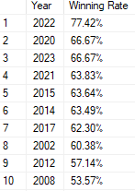

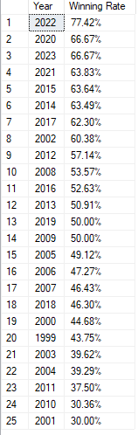

--How do home and away matches differ in each conference regarding the total number of games played, total number of wins, and the winning rate (calculated as the ratio of wins to total games)?

SELECT

c.confName AS "Conference Name",

p.gameType AS "Game Type",

COUNT(*) AS "Total Games",

FORMAT(SUM(CASE WHEN p.gameTeamScore > p.gameOpponentScore THEN 1 ELSE 0 END) * 100 / COUNT(*), 'N2') + '%' AS "Winning Rate"

FROM

[Game.Conference] c

JOIN

[Game.Perform] f ON f.confId = c.confId

JOIN

[Game.Play] p ON p.opntId = f.opntId

GROUP BY

c.confName,

p.gameType

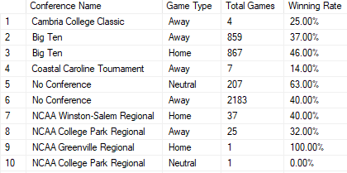

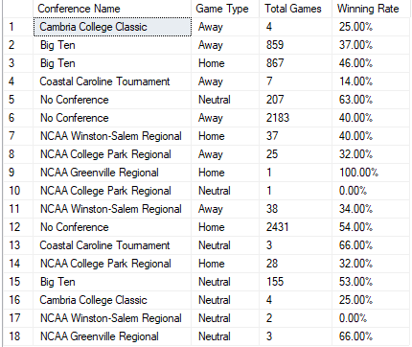

New additions to PPT

Question

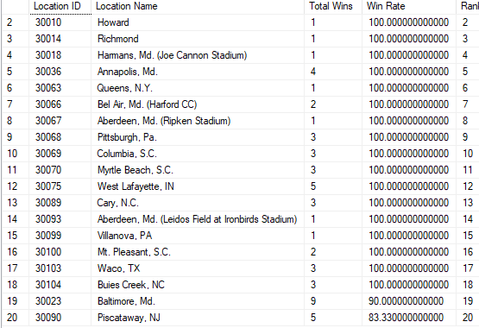

WITH StadiumRecords AS (

SELECT

p.locnId,

l.locnName,

COUNT(*) AS total_games,

SUM(CASE WHEN p.gameTeamScore > p.gameOpponentScore THEN 1 ELSE 0 END) AS total_wins,

COUNT(*) - SUM(CASE WHEN p.gameTeamScore > p.gameOpponentScore THEN 1 ELSE 0 END) AS total_losses,

ROUND(SUM(CASE WHEN p.gameTeamScore > p.gameOpponentScore THEN 1 ELSE 0 END) * 100.0 / COUNT(*), 2) AS winning_rate

FROM

[Game.Play] p

JOIN

[Game.Location] l ON p.locnId = l.locnId

GROUP BY

p.locnId, l.locnName

)

-- ...

SELECT

locnId AS "Location ID",

locnName AS "Location Name",

total_wins AS "Total Wins",

"Win Rate",

rnk AS "Rank"

FROM (

SELECT

locnId,

locnName,

total_games,

total_wins,

total_losses,

ROUND(winning_rate, 2) AS "Win Rate",

ROW_NUMBER() OVER (ORDER BY winning_rate DESC) AS rnk

FROM

StadiumRecords

) ranked

WHERE

rnk <=20

ORDER BY

"Win Rate" DESC;

Question

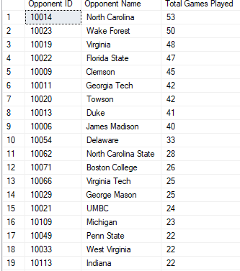

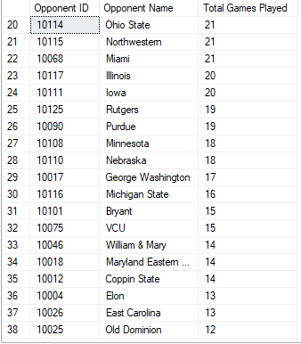

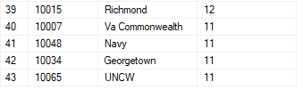

SELECT

opnt.opntId AS "Opponent ID",

opnt.opntName AS "Opponent Name",

COUNT(*) AS "Total Games Played"

FROM

[Game.Play] p

JOIN

[Game.Opponent] opnt ON p.opntId = opnt.opntId

WHERE

p.gameTeamScore IS NOT NULL

AND p.gameOpponentScore IS NOT NULL

AND p.opntId <> (SELECT teamId FROM [Game.Team] WHERE teamName = 'Maryland')

GROUP BY

opnt.opntId, opnt.opntName

HAVING

COUNT(*) > 10

ORDER BY

"Total Games Played" DESC;